**Annex I.**

**UNDP overview**

1. **Statement of financial performance for the year ended 31 December 2016**

(Thousands of United States dollars)



*Source:* Table 2a, DP/2017/30 Add.1. Annex 1 expenses presented based on cost classifications.

a/Includes general management support service cost.

b/This adjustment is required to remove the effect of internal UNDP cost recovery.

1. **Statement of financial position as at 31 December 2016**

(Thousands of United States dollars)



**Annex II.**

**Regular resources – comparison of budget to actual, 2016**

(Thousands of United States dollars)



**Annex III.**

1. **Integrated resources plan compared to 2014-2016 actuals**

(Millions of United States dollars)

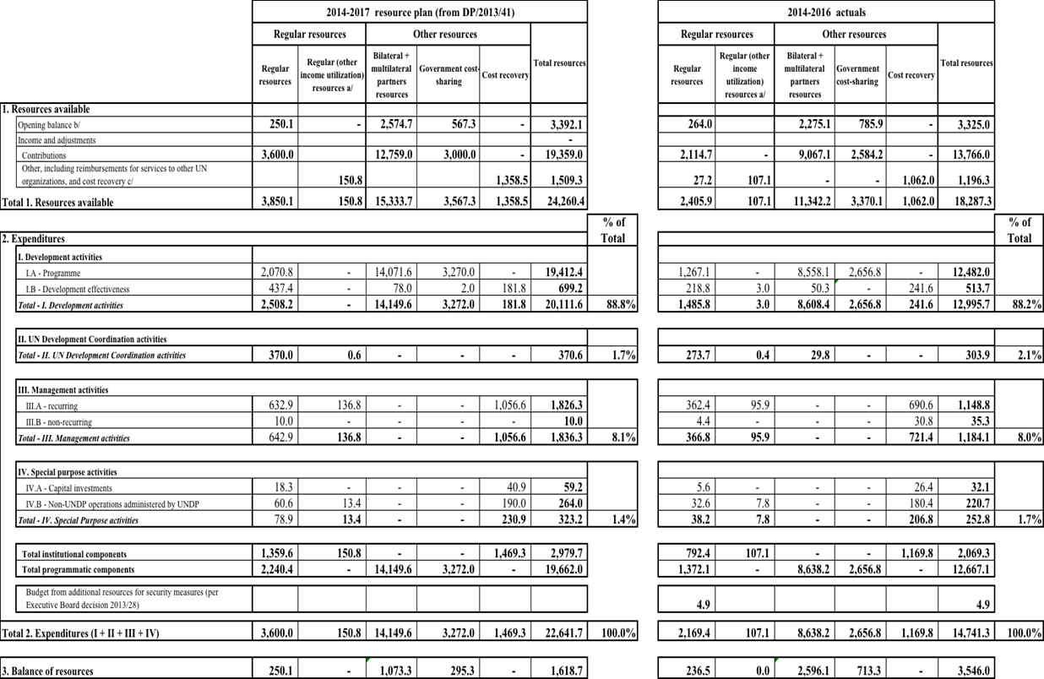



**Summary of institutional component of the integrated budget expenditures by category:**

**2014-2016 actual expenditures**

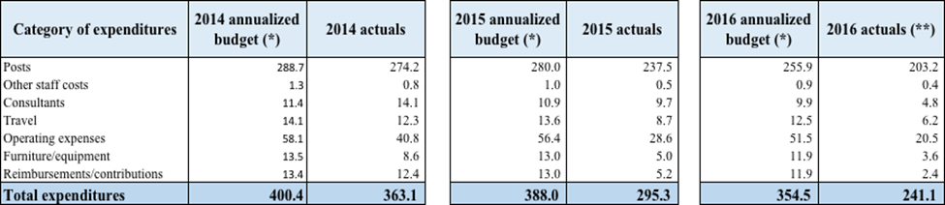

1. **Institutional components of the integrated resources plan by functional cluster**

**2014-2017 estimates compared with 2014-2016 actuals**

(Millions of United States dollars)



**C. Resources allocated to posts by location**

(Thousands of United States dollars)









**Annex IV.**

**United Nations Capital Development Fund – overview**

1. **Statement of financial performance for the year ended 31 December 2016**

(Thousands of United States dollars)



a/Includes general management support service cost.

b/This adjustment is required to remove the effect of internal UNDP cost recovery.

**B. Statement of financial position as at 31 December 2016**



**Annex V.**

**Explanations of terms used in DP/2017/30 and DP/2017/30/Add.1**

*Accounting linkage:* Available voluntary contributions from host governments that are transferred to the GLOC fund to offset the shortfalls for GLOC contributions for the reporting year as per UNDP Governing Council decision (84/9). Such accounting linkages are recorded and reported separately on the annual performance reports.

*Accumulated surplus:* Formerly referred to as ‘unexpended resources or unspent balance’. It represents accumulated funds at the end of the reporting period.

*Bilateral partners:* Governments of the Member States that contribute to UNDP regular resources and other resources, comprising the Development Assistance Committee of the Organisation for Economic Co-operation and Development (OECD/DAC) members, and non-members of OECD/DAC including programme countries.

*Certified Emission Reductions (CER)s:* Under the Kyoto Protocol industrialized countries are offered the opportunity to offset greenhouse gas (GHG) emissions by procuring credits from Clean Development Mechanism (CDM) projects located in developing countries. A CER basically allows an entity to pay for the reduction of GHG emissions elsewhere and is often more cost-effective than reducing the GHG emissions from their own operations or is used where GHG emissions cannot be avoided. UNDP is committed to buying only very credible, UNFCCC-issued credits (“Gold Standard”) which also deliver tangible sustainable development benefits. For details please refer to the EG-approved HQ Emission Reduction Strategy (<https://undp.unteamworks.org/node/369936>).

*Cost classification:* Set of criteria and the process of determining programme implementation vs. administration costs, and clarifying distinctions between those.

*Development activities:* Activities associated with ‘programmes’ and ‘development effectiveness,’ activities essential for achieving development results.

1. *Programmes:* Activities traced to specific programme components or projects, which contribute to delivering development results contained in country/regional/global programme documents or other programming arrangements.
2. *Development effectiveness activities:* Activities of a policy-advisory, technical and implementation nature needed to achieve the objectives of programmes and projects in UNDP’s areas of focus. While essential to the delivery of development results, they are not included in specific programme components or projects in country, regional, or global programme documents.

*Elimination:* Represents the accounting adjustment to remove the effect of internal UNDP cost-recovery revenue and general management support expense from total UNDP amounts.

*Expenditure:* Utilization of available financial resources, across harmonized cost classification categories

*Expenses:* Expenses include disbursements and accruals for goods received and services rendered, and the use or impairment of assets, dependent on the implementation arrangement.

*Funds administered by UNDP:* Funds established by the General Assembly and administered by UNDP. United Nations Capital Development Fund (UNCDF) is the only fund administered by UNDP.

*Government contributions towards local office costs* *(GLOC):* Contributions in the form of cash, or by provision in-kind of specific goods, services and facilities that a host Government makes towards meeting the expenses of maintaining a UNDP country office.

*Institutional budget:* The institutional component of the integrated budget covering activities over a period based on a set of defined results from the strategic plan.

*Integrated Results and Resources Framework (IRRF*): The IRRF translates the Strategic Plan 2014-2017 into results that allow UNDP and stakeholders to monitor achievements, learn lessons, and hold the organization accountable for the funds entrusted to it. It has been developed in accordance with the core principles set out in the approved document (DP/2013/40): that UNDP is a demand-driven organization and aligns its support behind national priorities. UNDP support under the outcomes and outputs below are decided at country level, based on national demand. Only Country Offices that provide support based on demand under a given outcome monitor the relevant indicators in respective output dimensions. The framework helps UNDP and the Executive Board to understand how well UNDP is contributing to development according to demand and plan; it is not for reporting on performance of programme countries (as per EB decision 2011/14).

*IPSAS:* *International Public Sector Accounting Standards*: Independently developed accounting standards which have been considered the best accounting practice by public sector organisations.

*Joint programmes:* Collective efforts through which United Nations organisations and national partners work together to prepare, implement, monitor and evaluate the activities aimed at effectively and efficiently achieving the Millennium Development Goals and other international commitments arising from United Nations conferences, summits, conventions and human rights instruments.

*Management activities:* Activities whose primary function is the promotion of the identity, direction and well-being of an organisation. These include executive direction, representation, external relations and partnerships, corporate communications, legal, oversight, audit, corporate evaluation, information technology, finance, administration, security and human resources.

*Management service agreements* (MSAs): Management service agreement (MSA) signed with a donor to prepare for receiving contributions to deliver management and other support services to recipient governments under a specific programme or project.

*Multilateral sources:* Multilateral partners, such as regional development banks, international financial institutions, United Nations organisations, foundations and the private sector, which contribute to other resources.

*Other expenses:* Expenses on activities other than those covered under the four broad cost classifications (i.e., development, management, United Nations development coordination and special purpose).

*Other resources:* Resources of a voluntarily funded organisation that are received for a specific programme purpose and for the provision of specific services to third parties. Resources that fall under this category are: cost-sharing, trust funds established by the Administrator, reimbursable support services and miscellaneous activities.

*Overall UNDP contributions:* Contributions to UNDP regular resources and other resources.

*Operational reserve:* A reserve established in 1979 by the Governing Council (now the Executive Board) of UNDP to ensure adequate liquidity of UNDP by funding such reserve through a defined formula that is calculated yearly.

*Regular resources:* Resources of UNDP which are commingled and untied. They include voluntary contributions, contributions from governmental, intergovernmental or non-governmental sources, and related interest earnings and miscellaneous income.

*Reimbursable support services and miscellaneous activities:* Resources of UNDP other resources (other than cost-sharing and trust funds). Such funds are received for the provision of management and other support services to third parties. It comprises the following activities: management services agreements; the Junior Professional Officer programme, reimbursable support services; the United Nations Volunteers programme, programme support to Resident Coordinators, and special purpose activities.

*Revenue: C*onsists of: (a) contributions; (b) investment revenue; and (c) other revenue (see below).

1. C*ontributions:* Contributions are recognised when contribution agreements are signed, or cash is received where no contribution agreement is required. Voluntary contributions may also include in-kind contributions and GLOC cash contributions provided by programme country governments.

*Contributions, net:* Net Contributions after returns of unused contributions to donors, and transfers of funds have been deducted.

*(b) Investment revenue:* interest inflows from UNDP investments

*(c) Other revenue: R*evenue from sources other than contributions and investments, for example, revenue from sale of goods and provision of services, such as procurement, training, and other services to governments, UN agencies and other parties, foreign exchange gains, common services and miscellaneous revenue, and cost recovery revenue.

*Renewable Energy Certificates (RECs:* Technically, HQ sources electricity that was generated by combustion of fossil fuels and nuclear power. For technical reasons, non-fossil fuel emitting electricity generation options in New York City are not presently available.  Instead, consumption of conventionally generated electricity may be complemented with the purchase of an equivalent amount (kW-hrs) of Renewable Energy Certificates. RECs are property rights to the environmental, social, and other non-power qualities of renewable electricity generation which can be sold separately from the physical electricity and hence enables the switching to ‘green’ power in locations such as NY where green power options are not available. In short, by buying RECs, we enable an increase in renewable power generation in other parts of the US equivalent to our local consumption of fossil fuel generated power.  For more detailed information on how the mechanism works see <http://www.epa.gov/greenpower/gpmarket/rec.htm>

*Special purpose activities:* Activities and associated costs of (a) capital investments; and (b) non-UNDP operations administered by UNDP.

*United Nations development coordination activities:* Activities and associated costs supporting the coordination of development activities of the United Nations system.

_____________